Week 2 – Network Design
Virtual Network
A virtual network named CTU_VNet_Michael was created in Azure to support the CTU Training Solutions cloud infrastructure.
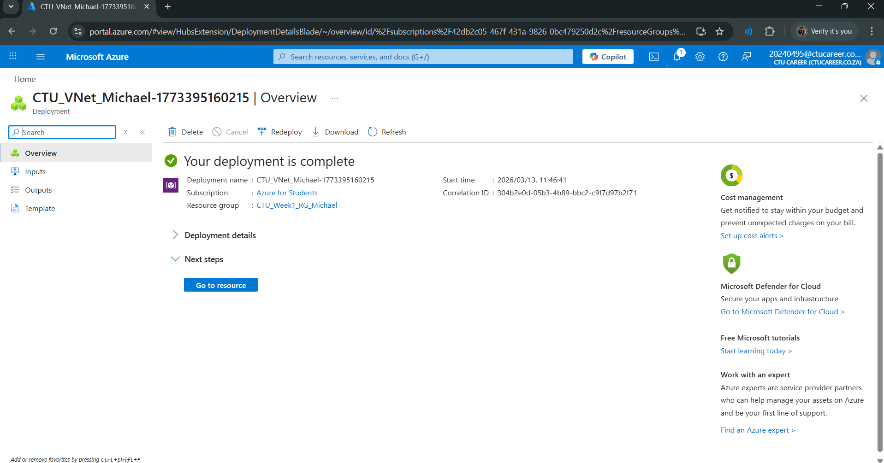

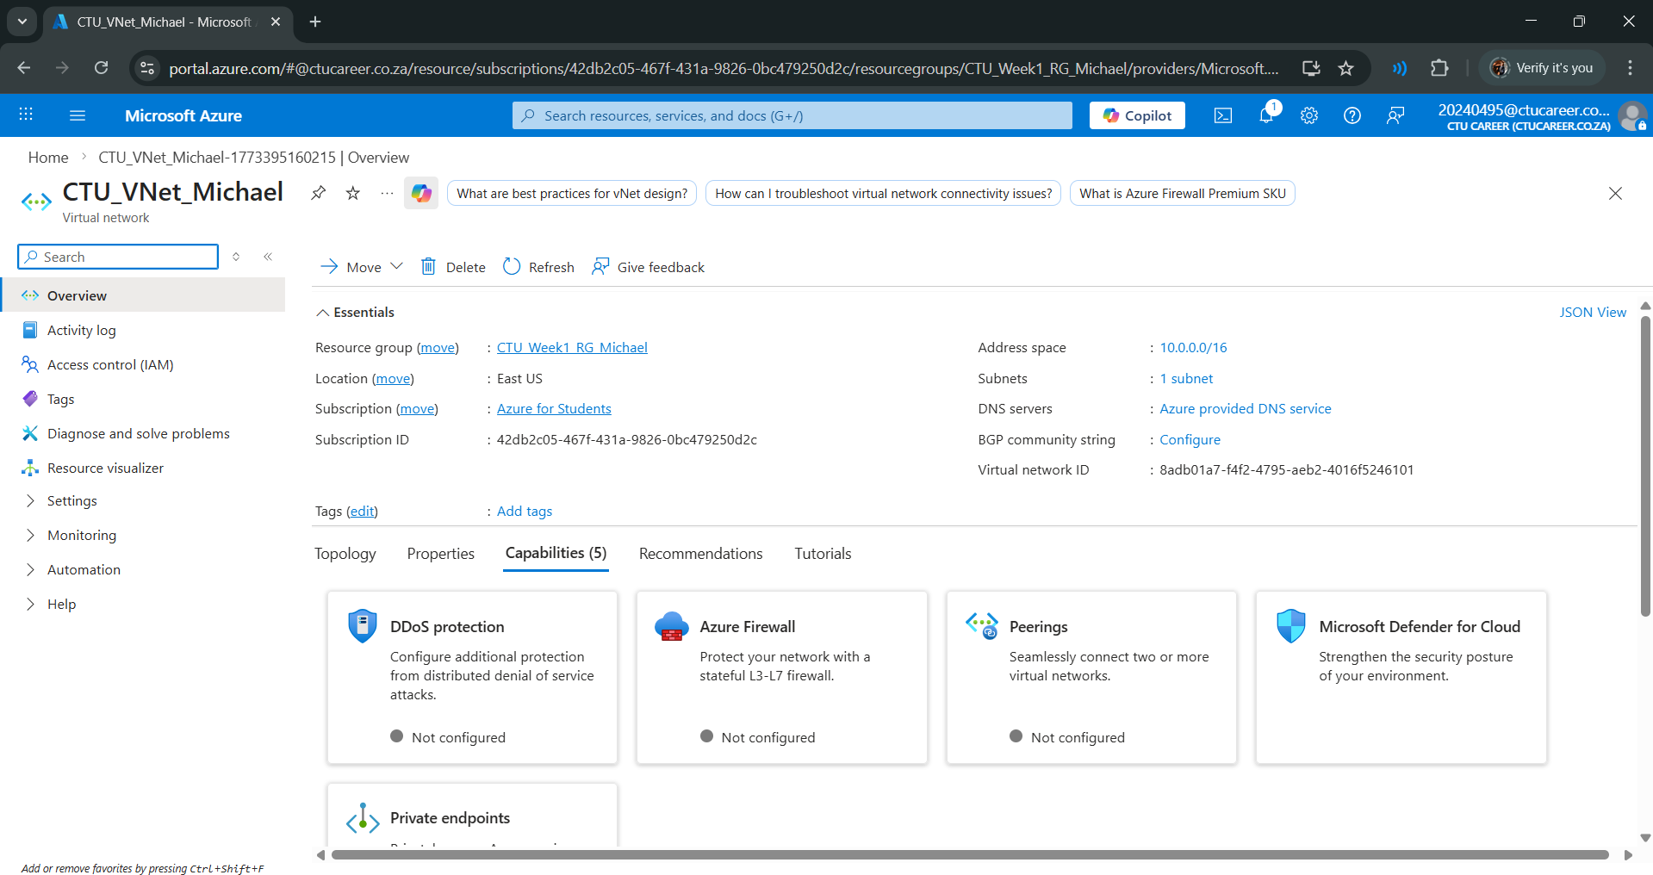
Figure 1The virtual network uses the address space 10.0.0.0/16, which allows multiple subnets to be created within the network. Two subnets were configured: 10.0.1.0/24 for the frontend subnet and 10.0.2.0/24 for the backend subnet.

